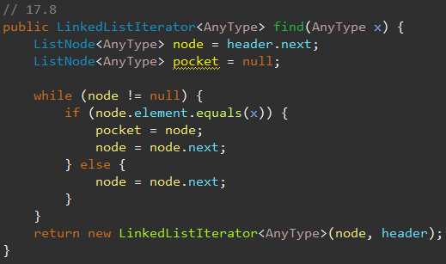Chapter 17 Programming

**17.8:** made the code go through the whole link list with a while loop. If I hit an x then I would keep it in a variable then check to see if there was a next one until I found the last instance of x.

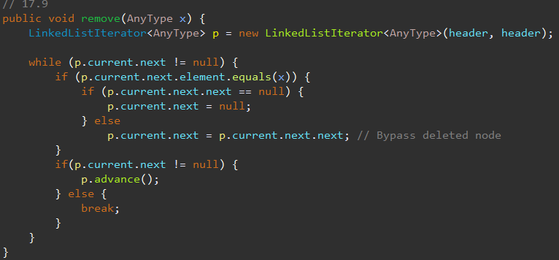**17.9:** I go through the linked list checking to see if the .next is equal to what I am looking for and if it is then I skip it by going next next twice.

**17.14:** for this one I did end up adding the front to the constructor so I could go through the link list from the beginning and find the spot before x by iterating through it and having a temp variable that was the current position so when I found the one before the current I just made the current equal the one before so it retreats.

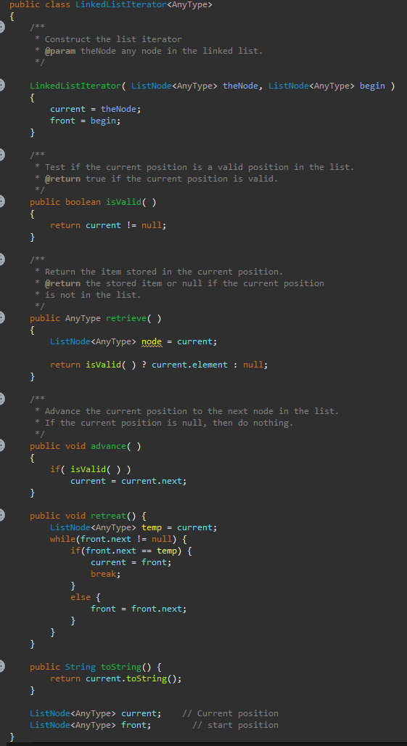

**17.17:**

in my ,method I had it start from the front of the list to check if it was there and it was I had a temp variable lag behind one to it could be the previous and if I found what I was looking for then I would make my temp point to the next next so it wasn’t pointing to nothing and I would have what I found the .next to point to the header to keep the information then I made it the new header.

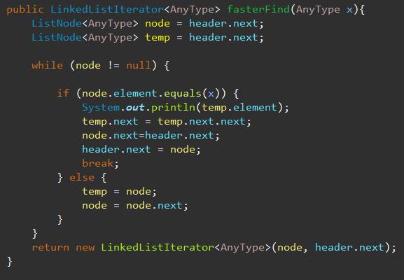

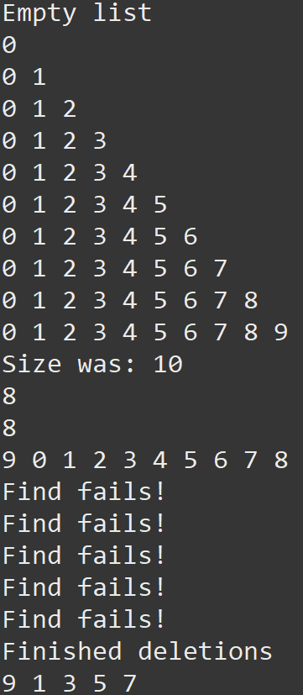here is my main where I tested some of the methods I made they all worked.